Trans’ Art
International Artist Residency Program

Founded in Paris, France, Trans’ Art International, a subsidiary company of Nongyuan Group, has been in charge of Nongyuan Group- Nongyuan International Art Village’s overseas projects. Nongyuan’s International Artist Residency Program had been officially launched in 2008 and since then, has focused on strengthening exchanges and visits among artists, art institutions, designers, art students and other art lovers from different countries and regions, providing them with interactive platforms and opportunities to understand different cultural heritages. Besides, it also promotes the interactions and cooperation between artists and art institutions as well as the development of culture and art industry.
Trans’ Art International has established partnerships with 12 universities and colleges in Sichuan Province to import and export art talents and offer both participators of this program and students chances to makes exchanges and cooperation: participators can share their knowledge, feelings, experience etc. with students through workshops or other academic activities; students can learn more about arts and their majors. The partnership will let all parties experience varied cultures and thoughts and broaden minds and horizons.

As an exhibition brand for Nongyuan Group, the "Image And Imagination”— the Chinese and foreign artists exchange exhibition has been successfully held in 40 countries, such as France, Germany, New Zealand, Hungary, Russia, Mauritius across four continents (Europe, Africa, Oceania, Asia) since its foundation in 2012. With over 100 activities like international exhibitions, forums and academic salons, it tries to offer the artists who participated in Nongyuan residency program an opportunity to go aboard and to expand their international influence.

- 2018 Artist Residency

- Program Introduction

In 2018, Trans’ Art International continues to promote international exchanges We invite artists from all over the world to participate in our Artist Residency Program, in which more chances of domestic and foreign exchanges and other exhibition activities will be offered. Participators of this program can also join in our annual activities

Trans’ Ar International 2018 international program
2018. June “Perception of Chengdu” China- Oceania Culture and Art Exchange Exhibition, New Zealand, Australia
2018. Sep. Image And Imagination Art Exchange Exhibition, Spain
2018. Nov. The 5th Chengdu Creativity & Design Week, Chengdu, China
2018. Dec. FESTIVAL 12X12, Paris，France

- Residence Duration

Residence Duration: Minimum one week. (7 days as a unit)

The residency length is based on the specific project plan of artists.

- Qualification of Applicants

This program is open to artists, art amateurs, designers, art students and art groups all over the world. And it mainly focuses on the field of contemporary art. There is no limitation for applicants’ usage of media during art creation. But specific requirements of each program should be confirmed by themselves.

- Application Procedure

Applicants should provide：
- CV:
- Latest CVs in English and French

- Applicants should ensure all information in the CVs is authentic.
- Note: naming of documents: for example, XX’s resume

- Collections of representative works with pictures and descriptions:
Collections of representative works should display applicants’ artistic features and fully represent their personal styles and thoughts. The description of works and creation processes should not exceed 500 words. The information must be in French and English.

Note:
- Documents of audios, videos, images, and texts must be sent in the form of MP3, MP4,
JPG or Word format.
- Files should be named as follows:
works: name of the artist and the work, category/ material, size, and creation year;
other documents:
for example, XX’s introduction of works
- Visual pictures should be no more than 10 with the minimum clarity of 1MB.
- Trans’ Art International has the right to use applicants’ documents (including applicants’ portraits and CVs), artworks (including audios, videos, images, and texts) for media promotion in the website and other activities.
- Project plan:
It refers to applicants’ creation plan which should be made by applicants first, containing overall arrangements and requirements such as time and space during the residency. Applicants can make specific changes in their plans to fit in Trans’ Art International’s projects and make proposes about exhibitions of their works, salons, lectures or exchanges. Then after confirming the final plan with Trans’ art International, the applicant will take the responsibility for extra arrangements. The plan should be in English and French.
- The Residency Application Form

- It is a major document. Please download and fill out it. The application should be completed in English or French. (Please download the Application Form from www.trans-art.net ）

- Upon preparation, please send documents to the official email at: residence@trans-art.net
with the title as application for Trans’ Art International Artist Residency Program.

- Exhibition of work
During residency, participating artists should regularly provide information to Trans’ Art International for related publicity and promotion. Artists will have regular meetings with related staff to discuss the progress and implementation of the plan. Participators will have opportunities to open workshops, academic discussions, salon talks, other educational exchanges and the final annual exhibition.

- Related rights and obligation（Condition）

(1) Trans’ Art International will provide artists not only the space, materials and accommodations during residency, but also publicity and media support, and then organize artists’ exchanges according to different programs.

(2) Trans’ Art International will build webpages in both Chinese and English for artists’ promotion in China. Trans’ Art International can also offer opportunities for annual exhibitions, work sale and promotions, if artists are willing to sign a long-term cooperation agreement with Trans’ Art International.

(3) Artists own creations during the residency (except works donated to Trans’ art International Artist Residency Program). However, the related expenses of transporting works shall be paid by artists themselves.
(4) Artists should take part in studio interaction, academic discussions, salons, lectures or related educational exchanges that are organized by Trans’ Art International and have opportunities to participate the final annual exhibition.

(5) With the artist’s consent, a piece of work or works created before or during the residency will be donated to Trans’ Art International Artist Residency Program.
Donation rules are as follows:

Painting 7 days residency: 50x80CM painting.
14 days residency: 2 pieces of 50x60CM paintings or 1 piece of 100X100CM painting. (According to the different type of painting, the rules can be changed.)

Photography
A representative piece of artists’ previous works shall be selected by Trans’ Art International as a donation with artists’ consent. The size of the donation is 50X60CM at least. 10 photographs artists created during residency shall be selected by Trans’ Art International and artists to own the copyright together
Note: As for the donation of other artistic categories such as sculpture, installation art, design, new media, drama, artists need to communicate with Trans’ Art International according to the program and artists’ residency plan.

(6)

After confirming the residency qualification, artists shall formally email their own consulate in Chengdu to apply for media support and project support in order to give more help to Trans’ Art International Artist Residency Program

6. Notice

Please do not send the original works or any other valuable documents to Trans’ Art International without consultation, or related materials will not be sent back. Information and materials applicants provided must be correct and authentic. Artists should take legal responsibilities for information they provided.
If applicants do not submit materials as Trans’ Art International ruled, they will miss the opportunity for residency this time.

7.Contact Us
For any questions about Trans’ Ar International Artist Residency Program, please contact:
Tel: +862885360589
Address: No.2576, Jin River 4 Section Shuang Liu District, Chengdu(双流区金河区4段2576号)

Email: residence@trans-art.net
Website: www.trans-art.net

Please download the map in our website.

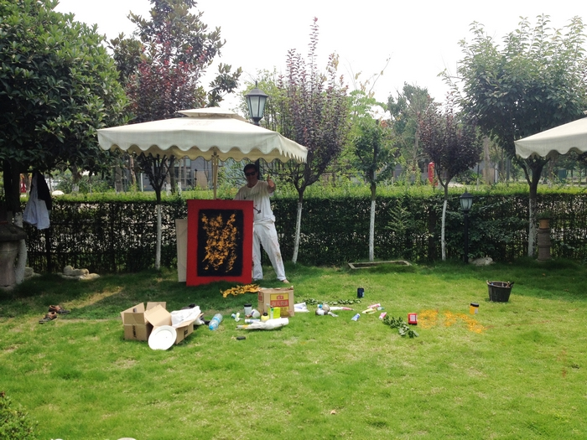
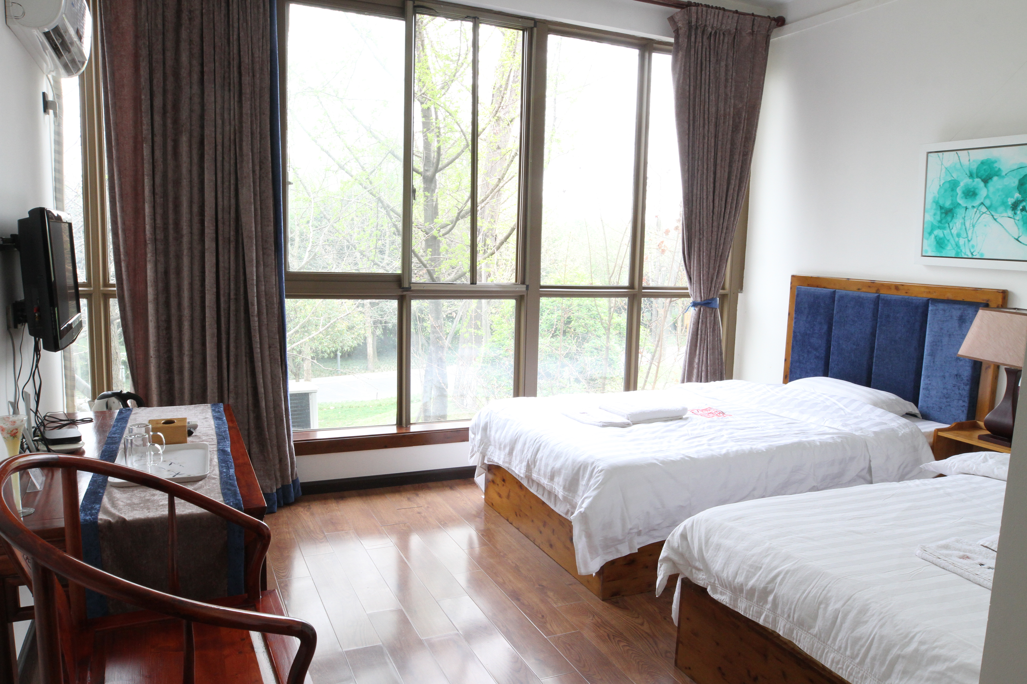

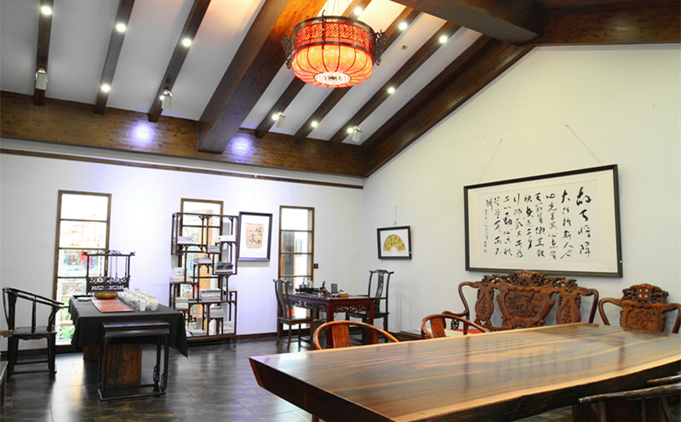
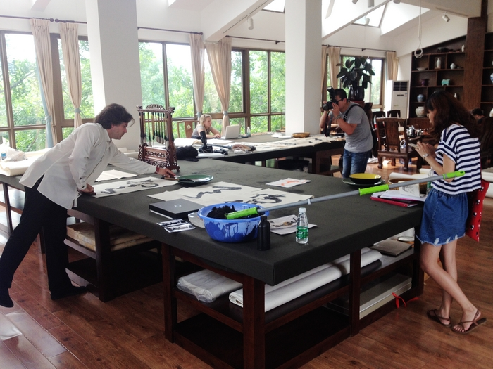

Annex one:

Chengdu Creativity and Design Week
Chengdu Creativity & Design Week, the famous and influential brand of cultural creativity industry, was held each year since 2014 by Chengdu Municipal Party Committee and People's Government. The first four sessions have attracted more than 10.75 million visitors and tourists, and the famous creativity and design organizations and professional designers from more than 30 countries, collected 9000 creativity and design award works, exhibited 120000 works with nearly 100 media having reported the event. In 2018, Nongyuan Group will continue to play an important role in Chengdu Creativity & Design Week, making itself the forefront, exhibition window and cooperation platform of international culture and design exchanges.

